**IMAGE FUSION USING MRI AND CT IMAGES**

### A PROJECT REPORT

***Submitted by***

## MAHIMA T P [REGISTER NO:211418104144] SOWMIYA K [REGISTER NO:211418104257] THOKALA VESHITHA [REGISTER NO:211418104294]

***in partial fulfillment for the award of the degree of***

## BACHELOR OF ENGINEERING

**IN**

**COMPUTER SCIENCE AND ENGINEERING**



## PANIMALAR ENGINEERING COLLEGE

**(An Autonomous Institution, Affiliated to Anna University, Chennai)**

### MAY 2022

PANIMALAR ENGINEERING COLLEGE

(An Autonomous Institution, Affiliated to Anna University, Chennai)

## BONAFIDE CERTIFICATE

Certified that this project report **IMAGE FUSION USING MRI AND CT IMAGES** is the bonafide work of **MAHIMA T P [211418104144], SOWMIYA K [211418104257], THOKALA VESHITHA [211418104294]** who carried out the

project work under my supervision.

### SIGNATURE SIGNATURE

**Dr.S.MURUGAVALLI,M.E.,Ph.D ., Dr.T.JACKULIN** **HEAD OF THE DEPARTMENT ASSOCIATE PROFESSOR**

### SUPERVISOR

DEPARTMENT OF CSE, DEPARTMENT OF CSE,

PANIMALAR ENGINEERING COLLEGE, PANIMALAR ENGINEERING COLLEGE, NASARATHPETTAI, NASARATHPETTAI,

POONAMALLEE, POONAMALLEE,

CHENNAI-600 123. CHENNAI-600 123.

Certified that the above candidate(s) was/ were examined in the Anna University Project Viva-Voce Examination held on...........................

**INTERNAL EXAMINER EXTERNAL EXAMINER**

## DECLARATION BY THE STUDENT

We **MAHIMA T P [211418104144], SOWMIYA K [211418104257],**

**THOKALA VESHITHA [211418104294]** hereby declare that this project report titled **IMAGE FUSION USING MRI AND CT IMAGES**, under the guidance of **DR.T.JACKULIN** is the orginial work done by us and we have not plagiarized or submitted to any other degree in any university by us.

## ACKNOWLEDGEMENT

We would like to express our deep gratitude to our respected Secretary and Correspondent **Dr.P.CHINNADURAI, M.A., Ph.D.** for his kind words and enthusiastic motivation, which inspired us a lot in completing this project.

We express our sincere thanks to our Directors **Tmt.C.VIJAYARAJESWARI**, **Dr.C.SAKTHI KUMAR,M.E.,Ph.D** and **Dr.SARANYASREE SAKTHI KUMAR**

**B.E.,M.B.A.,Ph.D.,** for providing us with the necessary facilities to undertake this project.

We also express our gratitude to our Principal **Dr.K.Mani, M.E., Ph.D.** who facilitated us in completing the project.

We thank the Head of the CSE Department, **Dr. S.MURUGAVALLI , M.E.,Ph.D.,**

for the support extended throughout the project.

We would like to thank my **Project Guide DR.T.JACKULIN** and all the faculty members of the Department of CSE for their advice and encouragement for the successful completion of the project.

### MAHIMA T P [211418104144] SOWMIYA K [211418104257]

**THOKALA VESHITHA [211418104294]**

### ABSTRACT

Fusing different medical images will increase the accuracy in diagnosis of disease and describe the complicated relationship between them for medical research. The existing methods are time consuming and also requires more number of samples to train the models. In this model, we will retrieve the complicated information from different medical images like Magnetic Resonance Imaging (MRI) and Computed Tomography (CT) by fusing them through multi-stage fusion networks. In the proposed model, we will use Dual Tree Complex Wavelet Transform (DTCWT) to extract the complicated and correlated information from each images and segmentation is done on fused image to get the segmented image. In the proposed method, the fusion of multi model medical images can be done by Dual Tree Complex Wavelet Transform, where the source medical image is converted to grayscale and decomposed, then the wavelet coefficients are extracted using DTCWT. After that, the approximation of wavelets are done to obtain the fused coefficients. Finally Inverse Dual Tree Complex Wavelet Transform is applied to obtain the final fused image. Additionally segmentation is performed to obtain the segmented image for the purpose of getting enhanced visual representation. In the proposed method, the improved quality of final fused image can be obtained.

## TABLE OF CONTETS

### CHAPTER NO TITLE PAGE NO

|  |  |  |
| --- | --- | --- |
|  | **ABSTRACT** | i |
|  | **LIST OF TABLES** | iv |
|  | **LIST OF FIGURES** | v |
|  | **LIST OF SYMBOLS, ABBREVIATIONS** | vi |
| **1.** | **INTRODUCTION** | 1 |
|  | 1.1 Scope of the project | 3 |
|  | 1.2 Objective of the project | 3 |
|  | 1.3 Problem Definition | 4 |
| **2. LITERATURE SURVEY** | | 5 |
| **3. SYSTEM ANALYSIS** | | 8 |
|  | 3.1 Existing System | 8 |
|  | 3.2 Proposed System | 11 |
|  | 3.2.1 Image Fusion Framework | 13 |
|  | 3.2.2 Vgg19 | 14 |
|  | 3.2.3 Dual Tree Complex Wavelet |  |
|  | Transform Algorithm | 15 |
|  | 3.2.4 Framework Modules | 18 |
|  | 3.3 Feasibility Study | 20 |
|  | 3.4 Hardware Environment | 21 |
|  | 3.5 Software Environment | 22 |

|  |  |  |
| --- | --- | --- |
| **CHAPTER NO**  **4.** | **TITLE**  **SYSTEM DESIGN** | **PAGE NO**  25 |
|  | 4.1 ER Diagram | 25 |
|  | 4.2 Data Dictionary | 26 |
|  | 4.3 Table Normalization | 27 |
|  | 4.4 Data Flow Diagram | 28 |
|  | 4.5 UML Diagram | 29 |
| **5.** | **SYSTEM ARCHITECTURE** | 33 |
|  | 5.1 Module Design Specification | 34 |
|  | 5.2 Algorithms | 37 |
| **6.** | **SYSTEM IMPLEMENTATION** | 43 |
|  | 6.1 Server-side Coding | 43 |
|  | 6.2 Client-side Coding | 46 |
| **7.** | **TESTING** | 47 |
|  | 7.1 Unit Testing | 48 |
|  | 7.2 Integration Testing | 49 |
|  | 7.3 Test Case and Reports | 49 |
| **8.** | **CONCLUSION** | 51 |
|  | 8.1 Results and discussions | 51 |
|  | 8.2 Conclusion and Future Enhancements | 51 |
|  | **APPENDICES** | 52 |
|  | A1 Sample Screenshots | 52 |
|  | **REFERENCES** | 57 |

**LIST OF TABLES**

|  |  |  |
| --- | --- | --- |
| **TABLE**  **NO** | **NAME OF THE TABLES** | **PAGE**  **NO** |

3.4.1 Hardware Specifications 21

3.5.1 Software Specifications 22

4.2.1 Data Set of each class 26

7.3.1 Test Cases for image fusion 49

**LIST OF FIGURES**

|  |  |  |
| --- | --- | --- |
| **FIGURE**  **NO** | **NAME OF THE FIGURES** | **PAGE**  **NO** |

|  |  |  |
| --- | --- | --- |
| 3.1.1 | Block Diagram of 1 Step 2-D DWT | 9 |
| 3.1.2 | Source CT image of a patient diagnosed by Sarcoma | 10 |
| 3.1.3 | Source MRI image of a patient diagnosed by Sarcoma | 10 |
| 3.1.4 | DWT Fused Image | 11 |
| 3.2.1 | Fusing CT and MRI image using python wavelet tool | 14 |
| 3.2.2 | VGG19 Architecture | 15 |
| 3.2.3 | Dual tree of real filters for DTCWT | 17 |
| 3.2.4 | 2-D impulse response of DTCWT at level 4 | 17 |
| 3.2.5 | Proposed Model Flow | 18 |
| 3.4.1 | Visual Studio Code | 22 |
| 4.1.1 | ER Diagram for image fusion | 25 |
| 4.2.1 | Sample CT image from data set | 27 |
| 4.2.2 | Sample MRI image from data set | 27 |
| 4.4.1 | 0-level DFD diagram for image fusion | 28 |
| 4.4.2 | Level-1 DFD diagram for image fusion | 29 |
| 4.5.1 | Use Case diagram for image fusion | 30 |
| 4.5.2 | Activity diagram for image fusion | 31 |
| 4.5.3 | Sequence diagram for image fusion | 32 |
| 5.1.1 | Architecture diagram for image fusion | 33 |

|  |  |  |
| --- | --- | --- |
| **FIGURE NO** | **NAME OF THE FIGURES** | **PAGE NO** |
| 5.1.2  5.1.3 | Decomposed image  Fused Image | 34  36 |
| 5.1.4 | Segmented Image | 36 |
| 5.2.1 | Typical wavelet associated with 2-D DTCWT for 6 sub-bands | 38 |
| 5.2.2 | VGG-19 Architecture Diagram | 42 |
| A 1.1 | Upload page in image fusion | 52 |
| A 1.2 | Coordinates Selection page in image fusion | 53 |
| A 1.3 | Registered Image display page in image fusion | 54 |
| A 1.4 | Fused Image display page in image fusion | 55 |
| A 1.5 | Segmented Image display page in image fusion | 56 |

**LIST OF ABBREVATIONS**

|  |  |  |
| --- | --- | --- |
| **S. NO** | **ABBREVATION** | **EXPANSION** |
| 1 | DTCWT | Dual Tree Complex Wavelet Transform |
| 2 | IDTCWT | Inverse Dual Tree Complex Wavelet Transform |
| 3 | CT | Computed Tomography |
| 4 | MRI | Magnetic Resonance Imaging |
| 5 | PET | Positron Emission Tomography |
| 6 | SPECT | Single Photon Emission Computed Tomography |
| 7 | PCA | Principal Component Analysis |

# CHAPTER 1 INTRODUCTION

X-ray, Positron Emission Tomography (PET), Single Photon Emission Computed

Tomography (SPECT), Magnetic Resonance Imaging (MRI), and Computed Tomography (CT) medical images, will not provide as much as detailed information for medical based research and diagnosis. They are required to provide a lot of elaborated clinical data.

Medical imaging systems will provide different medical information regarding tissue, that are complicated in most cases. For example, X-rays, are used for identify bone injuries and bone fractures, CT images will give the elaborated information of internal organs, tumors and blood vessels. MRI is used to provide the information about tissues. Whereas the SPECT will show how blood flows to tissues and organs, and finally PET is helps to reveal how the tissues and organs are functioning.

All these features will not be gathered from a single image, in order to extract all the complicated information from a single we are fusing the medical images of single or different systems. The medical image fusion is defined as the process of merging different kinds of medical images or of similar types into a single image that provides more accurate information for diagnosis that will be helpful for better and accurate treatment. The doctors will able to extract the detailed and complicated data from the fused images of the medical images which are not visible in individual images.

Medical image fusion tools are used in the medical department like oncology and cancer research therapy. A perfect image fusion process should get the complementary information of the source images in final fused image while neglecting the unwanted and unexpected features. Before getting into the image fusion process, the source image

should be preprocessed, that is the source image should be properly registered and aligned.

Image fusion can be done at three levels, they are pixel level, characteristics level and decision level. Pixel level fusion is designed to merge multiple source images into a final combined image, which will give more information for machine and human perception as compared to any of the source image. Next is the characteristics level image fusion is also referred as middle level image fusion. This process can represent and analyze the multi-sensor data for realizing classification. This technique plays a vital role in theoretical and analytical tool for image and signal processing. The final level of image fusion is decision level, this is the process of combining information at a higher level and also merge the results from various algorithm to get a final fused decision. Here the input images are processed individually for information extraction.

The most common technique for image fusion is Discrete Wavelet Transform (DWT). In this fusion the resultant image will have the information like spectral and directional moreover, the directional information will include more accurate information on horizontal, vertical and diagonal directions. The discrete wavelet transform has two shortcomings, one is shift variance and the other one is directionality. The shift variance will lead to errors in fused images due to some small movement presented in the source image, and also due to poor directionality, the source image will become difficult for processing the geometric features like contours and edges.

To overcome this, the proposed method will fuse the different medical images based on Dual Tree Complex Wavelet Transform (DTCWT). The dual tree complex wavelet transform will be the solution for the shortcomings of Discrete Wavelet Transform (DWT). The DTCWT will provide better directionality and the shift variance which is easy to process the edges and contours of the source image. Increased shift variance and increased directionality features of the DTCWT make fulfilled image fusion tool.

### SCOPE OF THE PROJECT

* + - The fusion of multi-modality images plays an important role in medical imaging field as the extension of clinical use of various medical imaging systems.
    - Different medical imaging techniques may provide scans with complementary and occasionally redundant information. The fusion of medical images can lead to additional clinical information not apparent in the single images.
    - The main scope ofthe project is to develop an efficient fusion technique to fuse single or multi modal images using Dual Tree Complex Wavelet Transform .

### OBJECTIVE OF THE PROJECT

* + - Medical imaging systems are helpful to detect various defects and issues in our body. Magnetic Resonance Imaging (MRI), Computed Tomography (CT), X-rays, Positron Emission Tomography (PET), and Single Photon Emission Computed Tomography (SPECT) are some types of medical imaging system.
    - Each will provide unique details, but none of these systems could provide all the required information in one single image. Medical image fusion is the solution for this problem.
    - One could gatherall the relevant information of different source images in a single image.

### PROBLEM DEFINITION

* + - CT ([computed tomography](https://townsenmemoria.wpengine.com/conditions/ct-scan/)) scans use X-rays. These images are used to detect abnormalities in both bone and softtissues, joint problems, tumors, cancer, heart disease, evidence of internal bleeding, or blood clots.
    - MRI stands for magnetic resonance imaging, and uses radio waves to generate images of the inside of your body. MRI scans look for abnormalities, inflammation, disease and tumors.
    - All these features will not be gathered from a single image, in orderto extract all the complicated information from a single we are fusing the medical imagesof single or different systems.
    - The doctors will able to extract the detailed and complicated data from the fused images of the medical images which are not visible in individual images.
    - The motivation is to obtain a superior exquisite image that will provide accurate and reliable statistics than any single image while retaining the best functions for the snapshots software program for medically testing, diagnosing and curing diseases.

**CHAPTER 2 LITERATURE SURVEY**

In 2016, Padmavathi K, Maya V KarKi, Mahima Bhat, Medical image fusion of different modalities using dual tree complex wavelet transform with PCA, in this paper different characteristics of low and high frequency sub bands are taken into account and fusion rules are applied. DTCWT is applied to extract salient information from each modality. Fusion rule is applied with PCA features. Improvement in visual quality can be seen in the proposed method.[2]

In 2013, Rajiv Singh, Ashish Khare, Multimodal medical image fusion using Daubechies complex wavelet transform, Shift sensitivity and lack of phase information in real valued wavelet transforms motivated to use DCxWT for multimodal medical image fusion. It was experimentally found that shift invariance and phase information properties improve the performance of image fusion in complex wavelet domain. Therefore, DCxWT is used for fusion of multimodal medical images.[3]

In 2013, Negar Chabi, Mehran Yazdi, Mohammad Entezarmahdi, An efficient image fusion method based on dual tree complex wavelet transform, Approximate shift- invariance property and availability of phase information in DTCWT are useful in the fusion process. The approximate shift-invariance property of DTCWT is important in robust sub-band fusion and also makes it to avoid loss of important image content at multiple levels. On the other hand, the availability of phase information in complex coefficients of DTCWT is useful in encoding more coherent structures of the fused images.[4]

In 2014, Himanshi, Vikrant Bhaterja Abhinav Krishn, and Akanksha Sahu, An improved Medical Image Fusion Approach Using PCA and Complex Wavelets, Unlike real valued discrete wavelet transforms, DTCWT provides shift invariance and improved directionality along with preservation of spectral content. The decomposed images are then processed using PCA a based fusion rule to improve upon the resolution and reduce the redundancy. Simulation results demonstrate an improvement in visual quality of the fused image supported by higher values of fusion metrics. [6]

In 2005, P.R.Hill, D.R.Bull & C.N Canagarajah, Image fusion using a new framework for complex wavelet transform ,This paper therefore introduces an alternative structure to the DT-CWT that is more flexible in its potential choice of filters and can be implemented by the combination of four normally structured wavelet transforms. The use of these more common wavelet transforms enables this method to make use of existing optimised wavelet decomposition and recomposition methods, code and filter choice.[10]

In 2004, S.Kor,U.S.Tiwary, feature level fusion of multimodal medical images in lifting wavelet transform domain, The feature fused is edge and boundary information of input images that is extracted using wavelet transform modulus maxima criterion. The image fusion performance is evaluated by standard deviation, entropy, cross entropy and gradient parameters. Experimental results show that the proposed method gives better results for image fusion as image contrast, average information content and detail information of fused image are increased.[13]

In 2012, B.Yang,S.Li, Pixel level image fusion with simultaneous orthogonal matching pursuit, Thus, this paper proposes a novel image fusion scheme using the [signal sparse](https://www.sciencedirect.com/topics/engineering/sparse-signal-representation) [representation](https://www.sciencedirect.com/topics/engineering/sparse-signal-representation) theory. Because image fusion depends on local information of source

images, we conduct the sparse representation on overlapping patches instead of the whole image, where a small size of dictionary is needed.[17]

In 2002, S.Li,J.T.Kwok, Y.Wang, Multifocus image fusion using artificial neural networks, This paper describes an application of artificial neural networks to this pixel level multifocus image fusion problem based on the use of image blocks. Experimental results show that the proposed method outperforms the discrete wavelet transform based approach, particularly when there is a movement in the objects or misregistration of the source images.[18]

In 2010, S.Daneshvar, H.Ghasemian, MRI and PET image fusion by combining IHS and retina-inspired models, he presented algorithm integrates the advantages of both IHS and RIM fusion methods to improve the functional and spatial information content. Visual and statistical analyses show that the proposed algorithm significantly improves the fusion quality in terms of: entropy, mutual information, discrepancy, and average gradient; compared to fusion methods including, IHS, Brovey, discrete [wavelet transform](https://www.sciencedirect.com/topics/computer-science/wavelet-transforms) (DWT), à-trous wavelet and RIM.[19]

In 1989, A.Toet, J.J.Van Ruyven, J.M,Valeton, Merging thermal and visula images by a contarst pyramid, This paper introduces a hierarchical image merging scheme based on a multiresolution contrast decomposition (the ratio of low-pass pyramid). The composite images produced by this scheme preserve those details from the input images that are most relevant to visual perception. The method is tested by merging parallel registered thermal and visual images. The results show that the fused images present a more detailed representation of the depicted scene. Detection, recognition and search tasks may therefore benefit from this new image representation.[20]

## CHAPTER 3 SYSTEM ANALYSIS

### EXISTING SYSTEM

In the field of medical image, imaging techniques such as Computed Tomography (CT), Magnetic Resonance Imaging (MRI), have provided clinicians with information of the human body’s structural characteristics, soft tissue, and so on. Different imaging methods keep different characteristics, and different sensors obtain different imaging information of the same part. The purpose of the fusion is to obtain better contrast, fusion quality, and perceived experience. Traditional medical image fusion methods are divided into spatial domain and transform domain.

The multimodel medical images like Computed Tomography (CT) and Magnetic Resonance Imaging (MRI) had been fused using Discrete Wavelet Transform. The combination of MRI and CT combines the advantages of clear bone information in CT images and the clear soft tissue of MRI images to compensate for the lack of information in a single imaging. Na et al. proposed a MRI and CT fusion algorithm based on guided filtering (GF). The fused image not only preserves the edge information of the source image but also extracts the feature information, which solves the problem of edge degree and clarity. The visual analysis of fusion results has obvious improvement in contrast and structural similarity.

Discrete wavelet transform can make different input frequency signals maintaining stable output and has good positioning in the time domain and frequency domain, which helps to preserve the specific information of the image. The discrete wavelet transform overcomes the limitations of the principle component analysis and has a good visual and quantitative fusion effect. The source image is preprocessed and enhanced, and the intensity component is extracted from the CT image using the IHS

transform, which preserves more anatomical information and reduces color distortion. The DWT transform is performed on the intensity components of MRI and CT to obtain high- and low-frequency sub-bands. The high- and low-frequency sub-bands are, respectively, fused by different fusion rules, and the inverse DWT transform is performed to obtain the fused image. Block diagram of 1 step 2-D DWT is shown in figure 3.1.

The absolute high-value method is used to fuse the decomposed high-frequency coefficients, the weighted average method is used to fuse the low-frequency coefficients, the predator-optimizer is used to estimate and optimize the weights, and finally, the inverse transform is used to obtain the fused images. The concept of fusion is done by applying two fusion rules. Low and high frequency coefficients have different meaning so different rules were applied to fuse them. First set of rules are, the larger wavelet coefficients mean salient features of images like corners and edges, selecting larger wavelet coefficient is the most common way to fuse details, because higher values mean stronger edges and are preferred as important part of information content. Low values of wavelet coefficients depict approximation of source images thus averaging is used to obtain information about both source images. After the approximation of the extracted wavelet coefficients, the Inverse Discrete Wavelet Transform is applied to obtain the fused image.

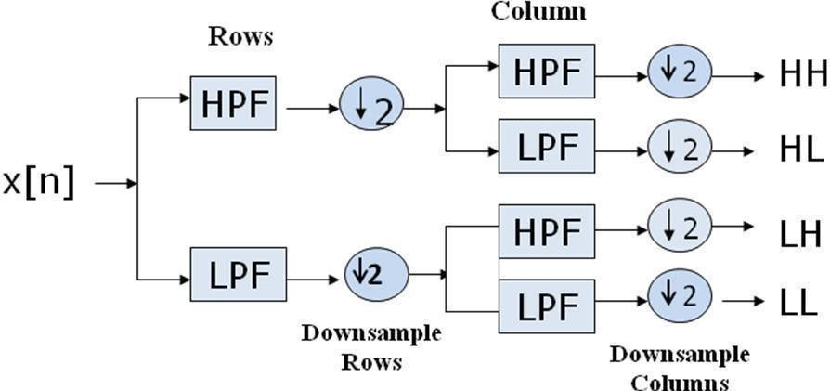

Fig. 3.1.1 Block Diagram of 1 step 2-D DWT

The CT image of a patient brain diseased by Sarcoma is shown in figure 3.2 and the MRI image of the same patient is shown in figure 3.3. These two multimodal images were fused by applying Discrete Wavelet Transform algorithm. After the extraction of the wavelet coefficients and further fusion rule is applied to fuse the coefficients.

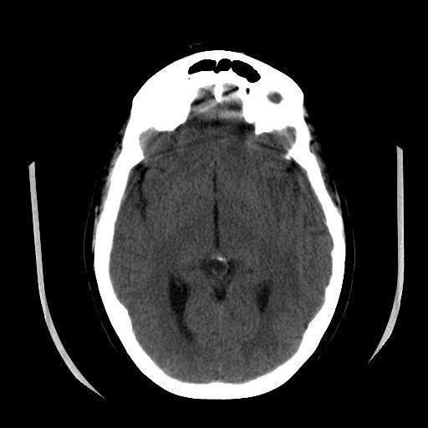

Fig 3.1.2 Source CT image of a patient diseased by Sarcoma

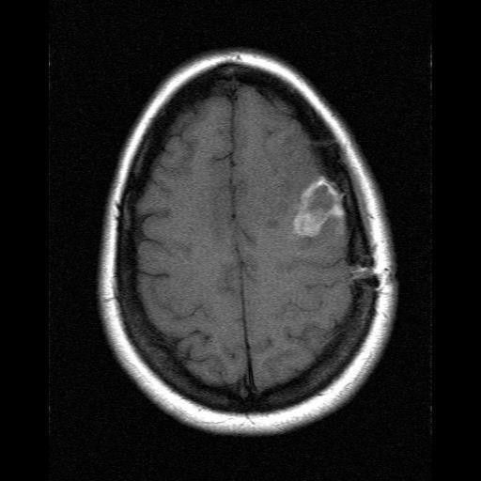

Fig 3.1.3 Source MRI image of a patient diseased by Sarcoma

After fusing the extracted wavelet coefficients using the derived fusion rules, the Inverse Discrete Wavelet Transform is applied to obtain the final fused image. The final fused image is shown in figure 3.4. The problems related with DWT are, it does not provide sufficient directional information and results in an image with shift variance and additive

noise. It also does not preserves time and frequency information and hence it is not as efficient to represent the enhanced visual representation of the fused image.

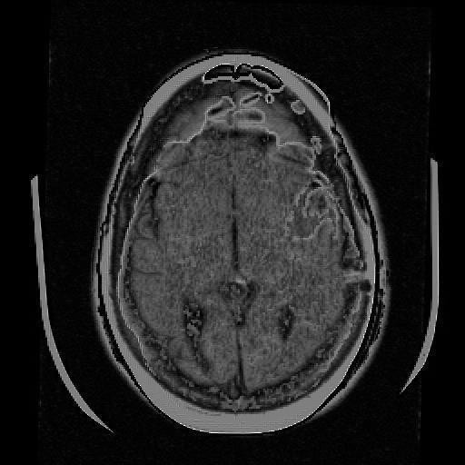

Fig. 3.1.4 DWT fused image

### PROPOSED SYSTEM

The medical image fusion is defined as the process of merging different kinds of medical images or of similar types into a single image that provides more accurate information for diagnosis that will be helpful for better and accurate treatment. The doctors will able to extract the detailed and complicated data from the fused images of the medical images which are not visible in individual images.

Medical image fusion tools are used in the medical department like oncology and cancer research therapy. A perfect image fusion process should get the complementary information of the source images in final fused image while neglectingthe unwanted and unexpected features. Image fusion can be done at three levels, they are pixel level, characteristics level and decision level. Pixel level fusion is designed

to merge multiple source images into a final combined image, which will give more information for machine and human perception as compared to any of the source image. Next is the characteristics level image fusion is also referred as middle level image fusion. This process can represent and analyze the multi-sensor data for realizing classification. This technique plays a vital role in theoretical and analytical tool for image and signal processing. The final level of image fusion is decision level,this is the process of combining information at a higher level and also merge the resultsfrom various algorithm to get a final fused decision. Here the input images are processed individually for information extraction.

MRI, also known as Magnetic Resonance Imaging, provides information on the soft tissue structure of the brain without functional information. The density of protons in the nervous system, fat, soft tissue, and articular cartilage lesions is large, so the image is particularly clear and does not produce artifacts. It has a high spatial resolution and no radiation damage to the human body, and the advantage of rich information makes it an important position in clinical diagnosis. The density of protonsin the bone is very low, so the bone image of MRI is not clear. The CT image is calledComputed Tomography imaging. The high-density absorption rate of bone tissue relative to soft tissue makes the bone tissue of the CT image particularly clear. CT images show less cartilage information, which represents anatomical information. SPECT is called Single-Photon Emission Computed Tomography, which is a functional image that displays the metabolism of human tissues and organs and the blood flow of arteries and veins. It provides good and malignant information of tumorsand is widely used in the diagnosis of various tumor diseases. However, the resolutionof SPECT is low and the positioning ability is poor. This framework is proposed by using the Anaconda tool, which is combined with Tensorflow, Keras, Numpy, Seaborn, Opencv, Pandas, Matplotlib, Pytorch, and Python3. The Tensorflow and Keras framework plays a vital role for image fusion. The performance that is measured

in this image fusion framework using DTCWT is entropy, standard deviation, peak signal to noise ratio, root mean square error and fusion factor.

### IMAGE FUSION FRAMEWORK

The proposed framework realizes Dual Tree Complex Wavelet Transform is implemented in the image fusion. The dual tree complex wavelet transform will be the solution for the shortcomings of Discrete Wavelet Transform (DWT). The DTCWT will provide better directionality and the shift variance which is easy to process the edges and contours of the source image. Increased shift variance and increased directionality features of the DTCWT make fulfilled image fusion tool. Medical imaging systems are helpful to detect various defects and issues in our body.Magnetic Resonance Imaging (MRI), Computed Tomography (CT), X-rays, Positron Emission Tomography (PET), and Single Photon Emission Computed Tomography (SPECT) are some types of medical imaging system. Each will provide uniquedetails, but none of these systems could provide all the required information in one single image. Medical image fusion is the solution for this problem. One could gather all the relevant information of different source images in a single image.

Figure 3.2.1 realizes the procedures done to fuse the two source medical images by Dual Tree Complex Wavelet Transform and to obtain the fused image. Firstly register the CT and MRI images, perform the wavelet decomposition, merge the two images, after decomposition, restoring the fused image.

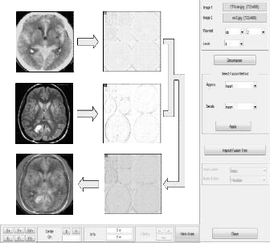

Fig. 3.2.1 Fusing CT and MRI images using Python wavelet tool

The principle of image fusion using wavelets is to merge the wavelet decompositions of the two original images using fusion methods applied to approximations coefficients and details coefficients. This provides tools for the analysis & Wavelet toolbox software, is a collection of many functions built on the PYTHON technical computing environment. It also helps to synthesis the deterministic and random signals of images using wavelets and wavelet packets usingthe PYTHON language.

### VGG 19

After the feature fusion , the image is passed to VGG-19 and the following procedure is implemented

* + - * A fixed size of (224 * 224) RGB image was given as input to this network which means that the matrix was of shape (224,224,3).
      * The only preprocessing that was done is that they subtracted the mean RGB value from each pixel, computed over the whole training set.
      * Used kernels of (3 * 3) size with a stride size of 1 pixel, this enabled them to cover the whole notion of the image.
      * Spatial padding was used to preserve the spatial resolution of the image.
      * Max pooling was performed over a 2 * 2 pixel windows with sride 2.
      * This was followed by Rectified linear unit(ReLu) to introduce non-linearity to make the model classify better and to improve computational time as theprevious models used tanh or sigmoid functions this proved much better than those.
      * Three fully connected layers are implemented from which first two were of size 4096 and after that a layer with 1000 channels and the final layer is a softmax function.

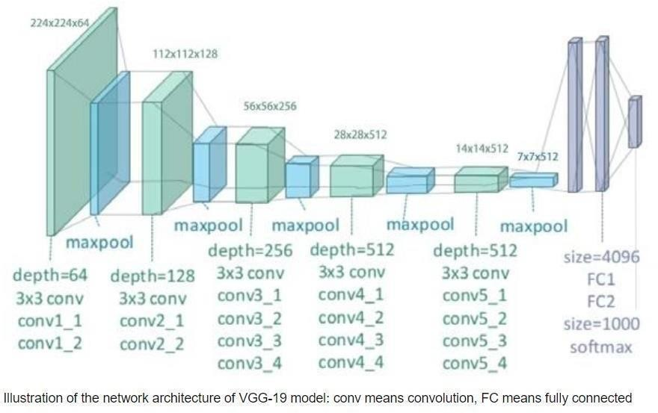

Fig 3.2.2 VGG19 Architecture

### DUAL TREE COMPLEX WAVELET TRANSFORM ALGORITHM

Dual Tree Complex Wavelets could provide approximate shift invariance and good directionality, but perfect reconstruction and achieving good frequency

characteristics was impossible using a single tree.

* However, approximate shift invariance could be obtained by doubling sampling rate at each level of tree. For this,samples must be spaced evenly. This could be acquired by eliminating downsamplingof 2 after level 1 filters, H0a and H1a.
* The real and imaginary parts of complex coefficients are showed in figure 3.2.4 Another way to achieve this goal is to use two parallel fully decimated trees, a and b.
* To get uniform intervals between samples of two trees below level 1, filters of one tree should have a half sample different delay fromother tree. To reach linear phase, this necessitates odd-length of filters in one treeand even-length filters in other tree.
* Greater symmetry exists between trees if even andodd filers are used in levels of tree, alternately. To invert the transform, PR filters areapplied in usual way to invert each tree separately and finally the two results are averaged.
* This process does not seem to yield a complex transform at all. The transform becomes complex if the outputs of two trees are defined as real and imaginary parts of complex wavelet.
* For filters of linear phase PR biorthogonal sets, even length filters have odd symmetry around their midpoints; meanwhile odd-length filters possess even symmetry. The impulse response of these filters look like the real and imaginary parts of complex wavelets.
* Extension to 2-D is achieved by separable filtering along columns and them rows. But, if column and row filters reject negative frequencies, only the first quadrant of 2-D signal spectrum is preserved.
* Two adjacent quadrants of the spectrum should represent a real 2-D signal, so filtering is performed with complex conjugates of the row filters, too. This gives 4:1 redundancy in the transformed 2-D signal.

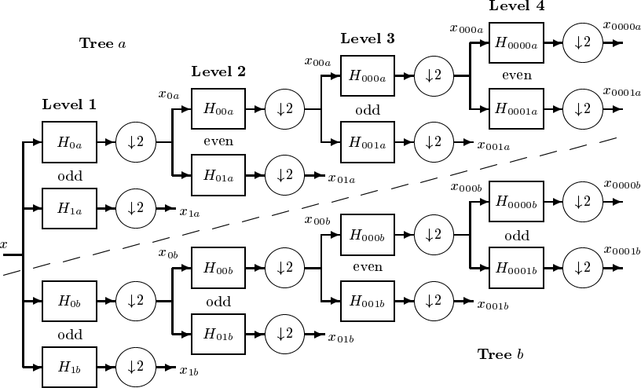

Fig. 3.2.3 Dual tree of real filters for DTCWT

A normal 2-D DWT yields three bandpass sub images at each level, horizontal details of image, vertical details and diagonal details.2-D DTCWT presents three sub images at each spectral quadrants 1 and 2, giving six bandpass sub images of complex coefficients at each level, oriented at angles of ±15, ±45,

±75. Their Gabor like impulse response is depicted in fig.3.2.4

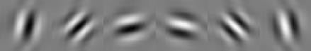

Real part

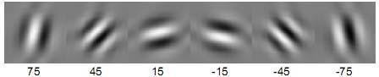

Imaginary part

Fig 3.2.4 2-D impulse response of DTCWT at level 4

### FRAMEWORK MODULES

The medical image fusion uses Dual Tree Complex Wavelet Transform algorithm, the flow chart of the image fusion frame work is shown in figure 3.2.5. The source images considered are the combination of MRI and CT images. The first step of the proposed scheme is to convert the RGB images into gray scale images. Then the gray scale images are decomposed by applying the dual tree complex wavelettransform (DTCWT). The wavelet coefficients and approximation are extracted from the decomposed images. The DTCWT will produce various levels of decomposed images. At each level the images are segmented into sub-bands at six directions like -15o, -45o,

-75o, 15o, 45o, 75o to extract the details from the image. On each sub-bands principal component analysis (PCA) is applied to extract the silent features.

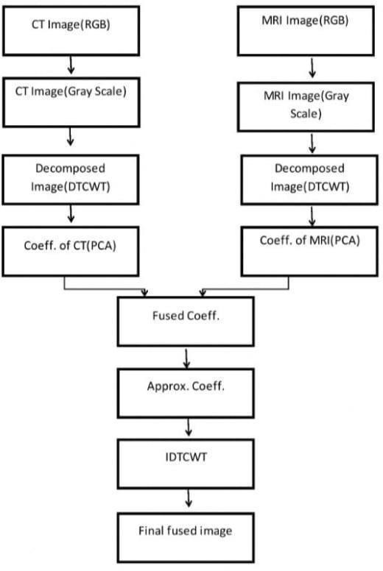

Fig. 3.2.5 Proposed model flow

Principal component analysis is used to reduce the dimension of the data, if the data is larger in size, also extract the silent and complementary features. The PCA will remove the unwanted and repeated information present in DTCWT. The PCA analysis has several steps. The first is standardization, the objective of this step is to standardize the range of the continuous initial variables. So, each will contribute equally to the analysis. Mathematically, standardization is done by finding the difference between each value and mean and finally dividing by standard deviation. The next step is to compute covariance matrix, some variables are highly correlated with other variables such a way that they contain redundant information. Hence, compute the covariance matrix to find the correlation. Further, compute the eigenvectors and eigenvalues of the covariance matrix with the aim to find the principal components. Next is to find the featured vector from all the computed principal vectors. Finally, reconstruct the data with the principal axes.

Fuse the extracted coefficients and its approximation by applying the fusion rule and to restore the fused image apply the inverse dual tree complex wavelet transform (IDTCWT). Finally segmentation is performed on the fused image to locate the objects and boundaries like lines and curves. It is the process of allocating artifact to each and every pixel in fused image, such that pixel having the same artifact show certain characteristics. Hence the colored image is obtained.

Steps of proposed algorithm is given as follows:

1. Source CT image 𝐼1(𝐼, 𝐼) and MRI image 𝐼2(𝐼, 𝐼) are converted into gray scale images.
2. The gray scale images 𝐼1(𝐼,𝐼) and 𝐼2(𝐼,𝐼) are decomposed into multiple levels using dual tree complex wavelet transform, to obtain the wavelet

coefficients 𝐼1ℎ𝐼(𝐼, 𝐼), 𝐼1ℎ𝐼(𝐼, 𝐼), 𝐼1𝐼𝐼(𝐼, 𝐼), 𝐼1𝐼𝐼(𝐼, 𝐼), and 𝐼2ℎ𝐼(𝐼, 𝐼),

𝐼2ℎ𝐼(𝐼, 𝐼), 𝐼2𝐼𝐼(𝐼, 𝐼), 𝐼2𝐼𝐼(𝐼, 𝐼)

1. PCA is applied to extract complementary information.
2. Approximation is applied to extract coefficients by PCA to form approximation of fused image.
3. Apply Inverse dual tree complex wavelet transform (IDTCWT) to get the final fused image.
4. Apply segmentation to obtain segmented image.

### FEASIBILITY STUDY

A feasibility study is an analysis that considers all of a project's relevant factors—including economic, technical, legal, and scheduling considerations—to ascertain the likelihood of completing the project successfully. Whether a project is feasible or not can depend on several factors, including the project's cost and [return on](https://www.investopedia.com/terms/r/returnoninvestment.asp) [investment](https://www.investopedia.com/terms/r/returnoninvestment.asp), meaning whether the project generated enough [revenue](https://www.investopedia.com/terms/r/revenue.asp) or sales from consumers. A feasibility study is an assessment of the practicality of a proposed plan or project.

A feasibility study analyzes the viability of a project to determine whether the project or venture is likely to succeed. The study is also designed to identify potential issues and problems that could arise from pursuing the project. As part of the feasibility study, project managers must determine whether they have enough people, financial resources, and the appropriate technology. The study must also determine the return on investment, whether it's measured as a financial gain or a benefit to society, as in the case of a non- profit.

**SOCIAL**

CT gives information about hard tissues and bones while MRI gives information about soft tissues. Doctors have to analyze these two scans separately and predict the problem of the patient. Fusing these medical images helps the doctor to analyze the problem better since fusion process here takes place without loss of information.

**TECHNICAL**

For fusion of CT and MRI images, there must be some technical needs which is affordable. Here the hardware requirements are Windows10, intel core i5 processor and ram of 4GB. Software requirements include visual code studio of latest version 1.67 and python of version 3.10 with necessary python packages installed.

### HARDWARE REQUIREMENTS

|  |  |
| --- | --- |
| **HARDWARE COMPONENTS** | **SPECIFICATIONS** |
| Processor | Intel Core |
| Operating System | Windows 10 (64-bit) |
| RAM | 8GB |

Table 3.4.1 Hardware Specifications

### Install the dependencies for Windows

**1.** Download & install Visual Studio Code latest version 1.67 and choose the Python 3.10 version. This automatically installs Python and many popular data scientist /ML libraries (*NumPy, Scikit-Learn, Pandas, R, Matplotlib etc..)*and hundreds of other open source packages for your future projects. [OpenCV](https://opencv.org/) library is not included though and we will install it separately as it is needed for real-time computer vision tasks.

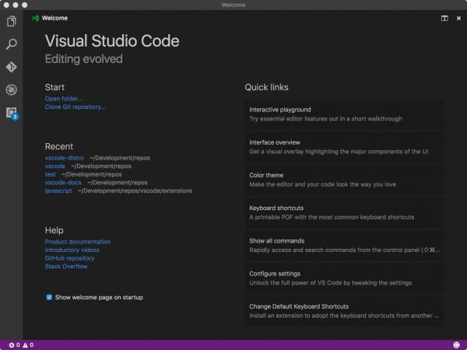

Fig. 3.4.1 Visual Studio Code

### SOFTWARE REQUIREMENTS

|  |  |
| --- | --- |
| **SOFTWARE** | **VERSION** |
| Flask | **2.1.2** |
| Numpy | **1.22.3** |
| Matplotlib | 3.5.2 |
| Imageio | 2.19.1 |
| Scipy | 1.8.0 |
| Torch | 1.11.0 |
| Torchvision | 0.12.0 |
| Scikit-image | 0.19.2 |
| Opencv | 4.5.1 |

Table 3.5.1 Software Specifications

### NumPy

NumPy is a library for the [Python programming language](https://en.wikipedia.org/wiki/Python_(programming_language)), adding support for large, multi-dimensional [arrays](https://en.wikipedia.org/wiki/Array_data_structure) and [matrices](https://en.wikipedia.org/wiki/Matrix_(math)), along with a large collection of [high-](https://en.wikipedia.org/wiki/High-level_programming_language) [level mathematical](https://en.wikipedia.org/wiki/High-level_programming_language) [functions](https://en.wikipedia.org/wiki/Function_(mathematics)) to operate on these arrays.

### Opencv

Python Opencv is a cross-platform library using which we can develop real-time computer vision applications. It mainly focuses on image processing, video capture and analysis including features like face detection and object detection. CV is the construction of explicit, meaningful descriptions of physical objects from their image. The output of computer vision is a description or an interpretation of structures in 3D scene. It is available for Windows, Mac OS X and Linux.

### Matplotlib

Matplotlib is a low level graph plotting library in python that serves as a visualization utility. Matplotlib was created by John D. Hunter. Matplotlib is open source and we can use it freely. Matplotlib is mostly written in python, a few segments are written in C, Objective-C and Javascript for Platform compatibility.

### Torchvision

Torchvision is a part of PyTorch. PyTorch is a library for Python programs that facilitates building **deep learning projects**. PyTorch emphasizes flexibility and allows deep learning models to be expressed in **idiomatic Python.** PyTorch is an open source machine learning library used primarily for applications such as computer vision and natural language processing. PyTorch is a strong player in the field of deep

learning and artificial intelligence, and it can be considered primarily as a research- first library.

### Scikit-image

Scikit-image (formerly scikits.image) is an open-source image processing library for the Python programming language. It includes algorithms for segmentation, geometric transformations, color space manipulation, analysis, filtering, morphology, feature detection, and more. It is designed to interoperate with the Python numerical and scientific libraries NumPy and SciPy.

**Flask**

Flask is a web framework that provides libraries to build lightweight web applications in python. It is developed by **Armin Ronacher** who leads an international group of python enthusiasts (POCCO). It is based on WSGI toolkit and jinja2 template engine. Flask is considered as a micro framework.

## CHAPTER 4 SYSTEM DESIGN

### ER DIAGRAM

In software engineering, an entity-relationship model (ERM) is an abstract and conceptual representation of data. Entity-relationship modeling is a database modeling method, used to produce a type of conceptual schema or semantic data model of a system, often a relational database, and its requirements in a top-down fashion. Diagrams created by this process are called entity-relationship diagrams, ER diagrams, or ERDs. **ER Diagram** stands for Entity Relationship Diagram, also known as ERD is a diagram that displays the relationship of entity sets stored in a database.

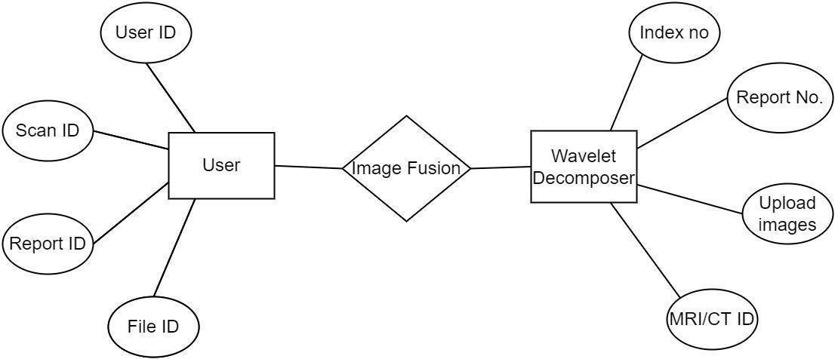

Fig 4.1.1 ER Diagram for image fusion

### DATA DICTIONARY

The dataset used here is The Whole Brain Atlas. This dataset provides CTand MRI images of the patients brain, which are affected by different brain diseases. The whole brain dataset contains RGB images as a static images, and it can be used for fusion. Each dataset contain two images mainly CT and MRI which contains the brain slices. The dataset are composed of 38 CT images and 38 MRI images, and labelled according and it is classified into two classes, mainly CT images, other is MRIimages.

|  |  |  |
| --- | --- | --- |
| **Main Class** | **Samples** | **Description** |
| CT | 38 | CT Images of diseased patient |
| MRI | 38 | MRI images of diseased patient |

Table 4.2.1 Data set of each class

The data set images has diseased brain slices, in general, the average image sizes has a spatial resolution around 512*512 pixels. The images are stored as JPEG where pixels value represents RGB colors.

The CT images has a volume of data that can be manipulated in order to demonstrate various bodily structures based on their ability to block the X-ray beam. Although, historically, the images generated were in the axial or transverse plane, perpendicular to the long axis of the body, modern scanners allow this volume of data to be reformatted in various planes or even as volumetric (3D) representations of structures. The CT image shows the structure and sizes of the tumors present the patient brain.

Magnetic Resonance Imaging (MRI) is a medical imaging technique used in radiology to form pictures of the anatomy and the physiological process of the body. MRI scanners use strong magnetic fields, which provides more detailed information of the tumors. Generally the MRI data set shows the brain tumors, traumatic brain

injury, developmental anomalies, multiple sclerosis, stroke, dementia, infection, and the causes of headache.

The datasets are stored in a folder in the local disk, when ever the source imageis put into the fusion, the patient image should be taken from the respective folder. During the fusion process the source image is converted into grayscale images which shows the image with full of intensities. The high intensity areas are spotted with whiteand low intensity areas are spotted with white. The datasets are stored in a folder in the local disk, when ever the source image is put into the fusion, the patient image should be taken from the respective folder. During the fusion process the source image is converted into grayscale images which shows the image with full of intensities. The high intensity areas are spotted with white and low intensity areas are spotted withwhite.

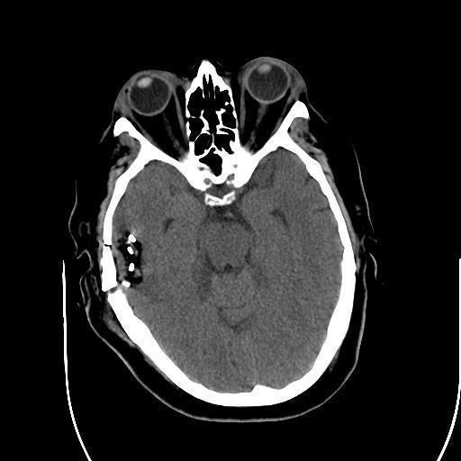

Fig. 4.2.1 Sample CT image from the dataset.

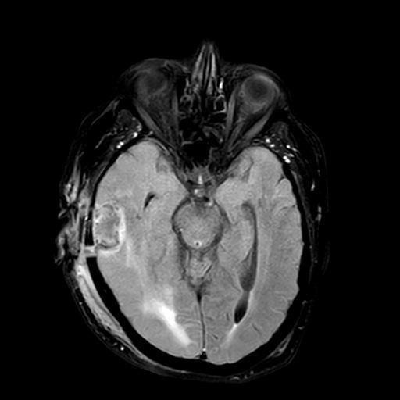

Fig. 4.2.2 Sample MRI image from the dataset

### TABLE NORMALIZATION

Normalization is a process of decomposing the relations into relations with

fewerattributes. Normalization is the process of organizing the data in the database. Normalization is used to minimize the redundancy from a relation or set of relations. It is also used to eliminate undesirable characteristics like Insertion, Update, and Deletion

Anomalies. Normalization divides the larger table into smaller and links them using

relationships. The normal form is used to reduce redundancy from the database table. The main reason for normalizing the relations is removing these anomalies. Failure to eliminate anomalies leads to data redundancy and can cause data integrity and other problems as the database grows.

### DATA FLOW DIAGRAMS

A data-flow diagram is a way of representing a flow of data through a process or a system (usually an information system). The DFD also provides information about the outputs and inputs of each entity and the process itself. A data-flow diagram has no control flow, there are no decision rules and no loops. There are several notations for displaying data-flow diagrams. For each data flow, at least one of the endpoints (source and / or destination) must exist in a process.

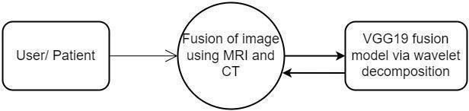

Fig 4.4.1 0-level DFD Diagram for image fusion

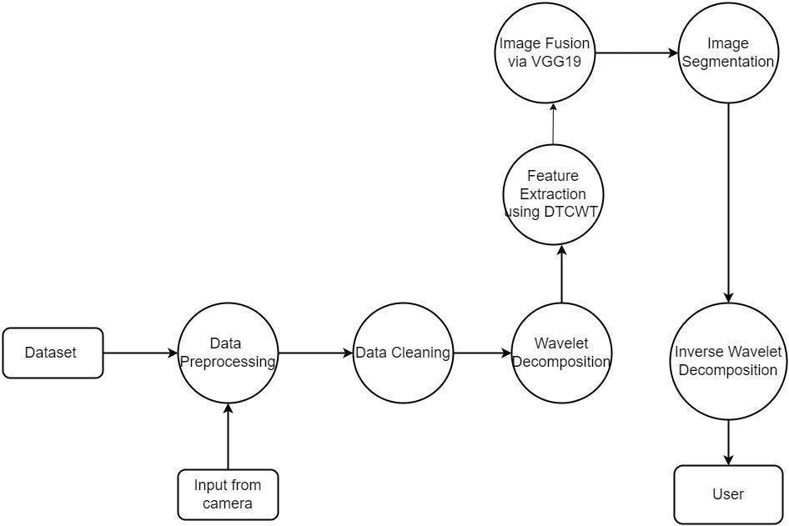

Fig 4.4.2 Level-1 DFD Diagram for image fusion

### UML DIAGRAMS

Design Engineering deals with the various UML [Unified Modeling language] diagrams for the implementation of project. Design is a meaningful engineering representation of a thing that is to be built. Software design is a process through which the requirements are translated into representation of the software. Design is the place where quality is rendered in software engineering. Design is the means to accurately translate customer requirements into finished product.

### USECASE DIAGRAM

A use case diagram is a type of behavioral diagram created from a Usecase analysis. The purpose of use case is to present overview of the functionality provided by the system in terms of actors, their goals and any dependencies between those use cases.

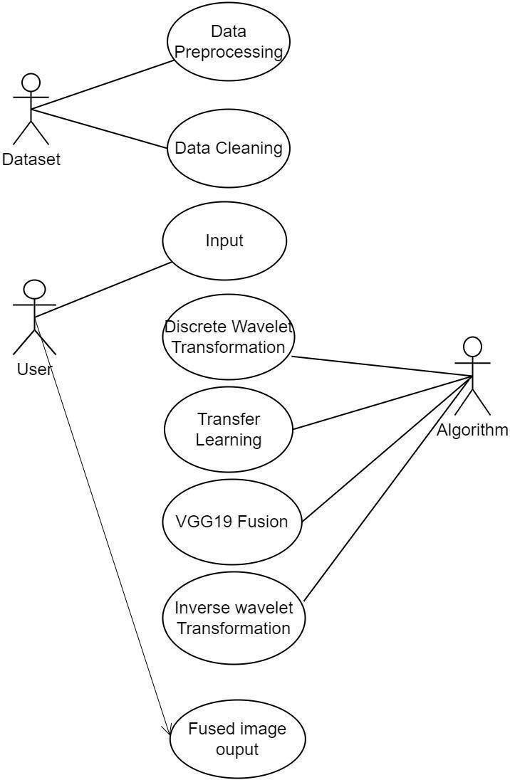

Fig 4.5.1 Use-case Diagram for image fusion

### ACTIVITY DIAGRAM

Activity diagram are a loosely defined diagram to show workflows of stepwise activities and actions, with support for choice, iteration and concurrency. UML, activity diagrams can be used to describe the business and operational step-by-step workflows of components in a system. UML activity diagrams could potentially model the internal logic of a complex operation. In many ways UML activity diagrams are the object- oriented equivalent of flow charts and data flow diagrams (DFDs) from structural development.

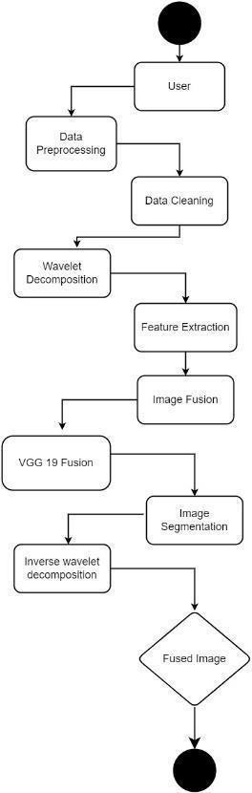

Fig 4.5.2 Activity diagram for image fusion

### SEQUENCE DIAGRAM

A sequence diagram in UML is a kind of interaction diagram that shows how the processes operate with one another and in what order. It is a construct of a message sequence chart. Sequence diagrams are sometimes called Event-trace diagrams, event scenarios, and timing diagrams. The below diagram shows the sequence flow shows how the process occurs in image fusion.

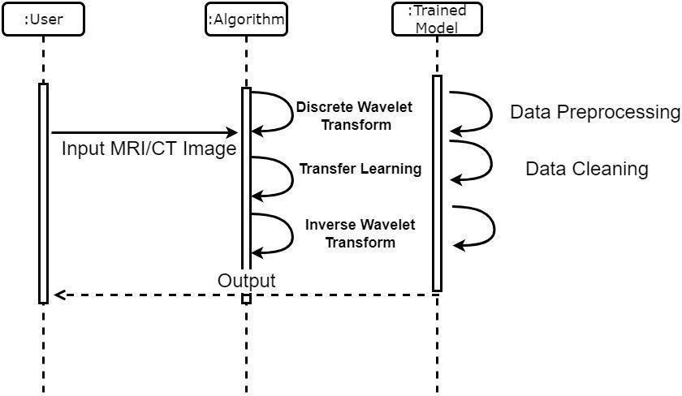

Fig 4.5.3 Sequence Diagram for image fusion

# CHAPTER 5 SYSTEM ARCHITECTURE

The diagrammatic representation of the system architecture is called the **system architecture diagram**. Figure 5.1.1 diagram gives us the abstract view of the components andtheir relationship with the system that makes the system work. The system architecturediagram acts as a blueprint and base of the system design by which the system can be upgraded, its issues can be mitigated, and can be used for the product selling or marketing.

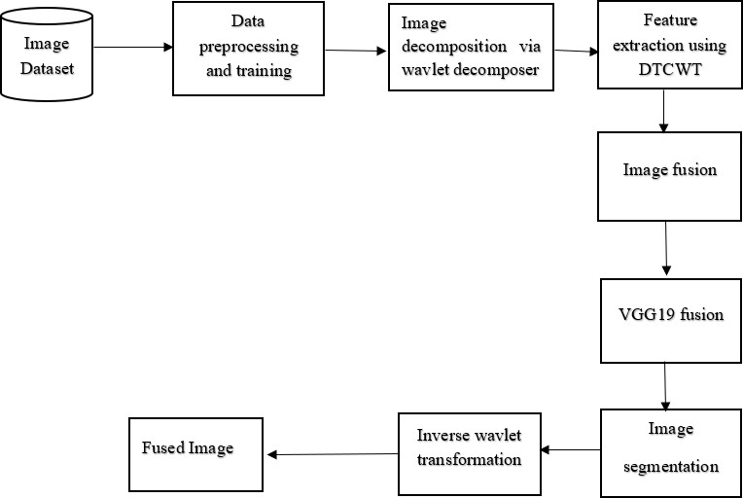

Fig 5.1.1 Architecture Diagram for image fusion

### MODULE DESIGN SPECIFICATION

According to the process it defines, the system is broken down into the following.

### Modules :

MODULE 1: Image Decomposition

MODULE 2: Extracting Features using DTCWT MODULE 3: Image fusion

MODULE 4: Image segmentation

### IMAGE DECOMPOSITION

In this module, we developed a website, which will prompt the user to upload the CT and MRI image of a patient. The CT and MRI image will be in the size of 512*512. and also we need to give the input as the maximum coordinate, to fix the coordinate in the uploaded source image for the purpose of fusion. The uploaded image is in the form of RGB. This RGB image is converted into gray scale image, which has the intensity information. After that these source gray scale CT and MRI image is decomposed using DTCWT. The decomposed image is shown in figure 5.1.1.

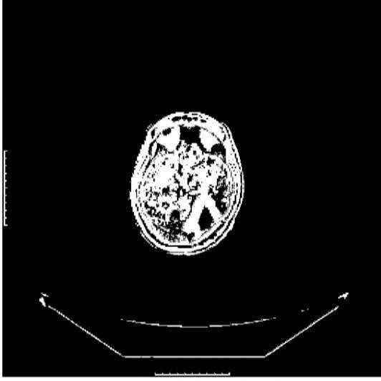

Fig 5.1.2 Decomposed Image

### EXTRACTING FEATURES USING DTCWT

After decomposition we will extract the high intensity and low intensity features as wavelet coefficients. It produce the various levels of decomposed images. Each level the images are segmented into sub-bands at six directions like -15o, -45o, - 75o, 75o, 45o, 15o to extract the features from the image.

Principal component analysis is used to reduce the dimension of the data, if the data is larger in size, also extract the silent and complementary features. As the medical images are larger, to reduce the data here, PCA is used. The PCA will remove the unwanted and repeated information present in DTCWT. The PCA analysis has several steps. The first is standardization, the objective of this step is to standardize the range of the continuous initial variables. So, each will contribute equally to the analysis.

Mathematically, standardization is done by finding the difference between each value and mean and finally dividing by standard deviation. The next step is to compute covariance matrix, some variables are highly correlated with other variables such a way that they contain redundant information. Hence, compute the covariance matrix to find the correlation. Further, compute the eigenvectors and eigenvalues of the covariance matrix with the aim to find the principal components. Next is to find the featured vector from all the computed principal vectors. Finally, reconstruct the data with the principal axes.

**IMAGE FUSION**

The extracted coefficients are approximated. Finally, we get the approximated wavelet coefficients. Now the image fusion, that is approximated coefficients are fused to get the fused coefficients. Now we apply the Inverse dual tree complex wavelet transform to restore the fused image. The fused image is shown in figure5.1.2.

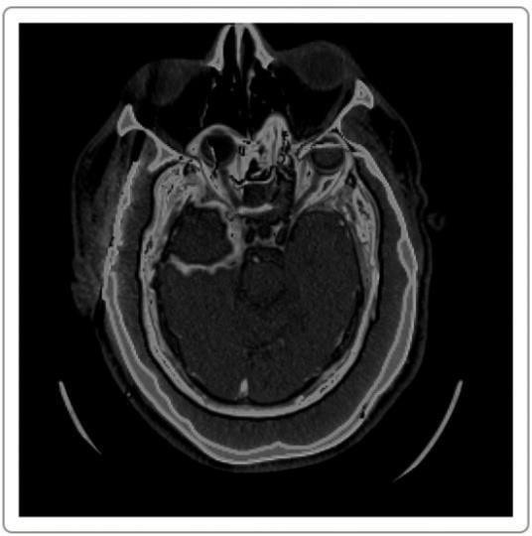

Fig 5.1.3 Fused Image

### IMAGE SEGMENTATION

Image segmentation is a branch of digital image processing which focuses on partitioning an image into different parts according to their features and properties. The primary goal of image segmentation is to simplify the image for easier analysis. In image segmentation, you divide an image into various parts that have similar attributes.

Watershed algorithm is used for [segmentation in some complex images](https://en.wikipedia.org/wiki/Image_segmentation). Watershed algorithm is based on extracting sure background and foreground and then using markers will make watershed run and detect the exact boundaries. This algorithm generally helps in detecting touching and overlapping objects in image. So the segmentation is performed on the final fused image. The segmented image is shown in figure 5.1.3.

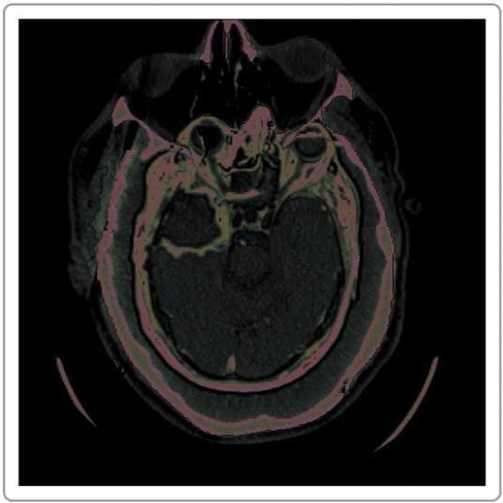

Fig 5.1.4 Segmented Image

### ALGORITHMS

**DUAL TREE COMPLEX WAVELET TRANSFORM**

The dual-tree complex wavelet transform (DTCWT) solves the problems of shift variance and low directional selectivity in two and higher dimensions found with the commonly used discrete wavelet transform (DWT). It has been proposed for applications such as texture classification and content-based image retrieval. The dual- tree complex wavelet transform (DTCWT), first introduced by Kingsbury in 1998 [10, 11], is approximately shift invariant and allows directional wavelets in 2 and higher dimensions with only 2x redundancy in 1D (2d for -dimensional signals, in general).

* + - Dual Tree Complex Wavelets could provide approximate shift invariance and good directionality, but perfect reconstruction and achieving good frequency characteristics was impossible using a single tree.
    - However, approximate shift invariance could be obtained by doubling sampling rate at each level of tree. For this,samples must be spaced evenly. This could be acquired by eliminating downsamplingof 2 after level 1 filters, H0a and H1a. The real and imaginary parts of complex coefficients are showed in figure 5.2.1
    - Another way to achieve this goal is to use two parallel fully decimated trees, a and b. To get uniform intervals between samples of two trees below level 1, filters of one tree should have a half sample different delay from other tree. To reach linear phase, this necessitates odd-length of filters in one treeand even-length filters in other tree.
    - Greater symmetry exists between trees if even and odd filers are used in levels of tree, alternatey. To invert the transform, PR filtersare applied in usual way to invert each tree separately and finally the two results are averaged.
* This process does not seem to yield a complex transform at all. The transform becomes complex if the outputs of two trees are defined as real and imaginary parts of complex wavelet.
* For filters of linear phase PR biorthogonal sets, even length filters have odd

symmetry around their midpoints; meanwhile odd-length filters possess even symmetry. The impulse response of these filters look like the real and imaginary parts of complex wavelets.

* Extension to 2-D is achieved by separable filtering along columns and them rows. But, if column and row filters reject negativefrequencies, only the first quadrant of 2-D signal spectrum is preserved.
* Two adjacentquadrants of the spectrum should represent a real 2-D signal, so filtering is performedwith complex conjugates of the row filters, too. This gives 4:1 redundancy in the transformed 2-D signal.
* A normal 2-D DWT yields three bandpass sub images at eachlevel, horizontal details of image, vertical details and diagonal details.2-D DTCWT presents three sub images at each spectral quadrants 1 and 2, giving six bandpass subimages of complex coefficients at each level, oriented at angles of ±15, ±45, ±75.

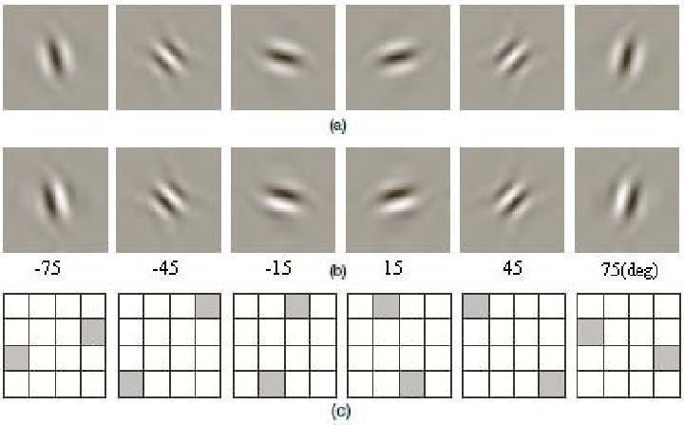

Fig 5.2.1 Typical wavelets associated with 2-D DTCWT for 6 sub-bands.

### PRINCIPAL COMPONENT ANALYSIS

Principal component analysis (PCA) is a technique to bring out strong patterns in a dataset by supressing variations. It is used to clean data sets to make it easy to explore and analyse. The algorithm of Principal Component Analysis is based on a few mathematical ideas namely:

* Variance and Convariance
* Eigen Vectors and Eigen values

We will explain the two topics in simple terms in the steps below so that you can follow along and learn enough to implement your own Principal Component Analysis code in any language.

**Algorithm steps Step 1:** Get your data

Separate your data set into Y and X. Y will be the validation set and X will be the training

set. In simple terms, we will use X for our study and use Y to check whether our study is correct.

**Step 2:** Give your data a structure

Take the 2 dimensional matrix of independent variables X. Rows represent data items and columns represent features. The number of columns is the number of dimensions.

For each column, subtract the mean of that column from each entry. (This ensures that each column has a mean of zero.)

**Step 3:** Standardize your data

Given the columns of X, are features with higher variance more important than features with lower variance, or is the importance of features independent of the variance? (In this case, importance means how well that feature predicts Y.)

If the importance of features is independent of the variance of the features, then divide each observation in a column by that column’s standard deviation. Call the centered and standardized matrix **Z**.

**Step 4:** Get Covariance of Z

Take the matrix Z, transpose it and multiply the transposed matrix by Z.

**Convariance of Z = ZᵀZ**

The resulting matrix is the covariance matrix of Z, up to a constant.

**Step 5:** Calculate Eigen Vectors and Eigen Values

Calculate the eigenvectors and their corresponding eigenvalues of ZᵀZ.

The eigen decomposition of ZᵀZ is where we decompose ZᵀZ into PDP⁻¹, Where P is the matrix of eigenvectors,D is the diagonal matrix with eigenvalues on the diagonal and values of zero everywhere else.

The eigenvalues on the diagonal of D will be associated with the corresponding column in P—  th  at is, the first element of D is λ₁ and the corresponding eigenvector is the first column of P. This holds for all elements in D and their corresponding eigenvectors in P. We will always be able to calculate PDP⁻¹ in this fashion.

**Step 6:** Sort the Eigen Vectors

Take the eigenvalues **λ₁, λ₂, …, λp** and sort them from largest to smallest. In doing so, sort the eigenvectors in P accordingly. (For example, if λ3 is the largest eigenvalue, then take the third column of P and place it in the first column position.)

Call this sorted matrix of eigenvectors P*. The columns of P* are the same as the columns of P in a different order. Note that these eigenvectors are independent of one another.

**Step 7:** Calculate the new featuresCalculate Z* = ZP*.

This new matrix, Z*, is a centered/standardized version of X but now each observation is a combination of the original variables, where the weights are determined by the eigenvector. As a bonus, because our eigenvectors in P* are independent of one another, each column of Z* is also independent of one another.

**Step 8**: Drop unimportant features from the new set

We need to determine which features from the new set we wish to keep for further study.

Side note: As each eigenvalue is roughly the importance of its corresponding eigenvector, the proportion of variance explained is the sum of the eigenvalues of the features you kept divided by the sum of the eigenvalues of all features.

**VGG-19**

After the feature fusion , the image is passed to VGG-19 and the following procedure is implemented

* A fixed size of (224 * 224) RGB image was given as input to this network which means that the matrix was of shape (224,224,3).
* The only preprocessing that was done is that they subtracted the mean RGB value from each pixel, computed over the whole training set.
* Used kernels of (3 * 3) size with a stride size of 1 pixel, this enabled them to cover the whole notion of the image.

Spatial padding was used to preserve the spatial resolution of the image.

* Max pooling was performed over a 2 * 2 pixel windows with sride 2.
* This was followed by Rectified linear unit(ReLu) to introduce non-linearity to make the model classify better and to improve computational time as the previous models used tanh or sigmoid functions this proved much better than those.
* Three fully connected layers are implemented from which first two were ofsize 4096 and after that a layer with 1000 channels and the final layer is a softmax function.



Fig 5.2.2 VGG-19 architecture diagram

**CHAPTER 6 SYSTEM IMPLEMENTATION**

* 1. **SERVER SIDE CODING**

# VGG19 CNN For Fusion

class VGG19(torch.nn.Module):

def init (self, device='cpu'): super(VGG19, self). init ()

features = list(vgg19(pretrained=True).features)if device == "cuda":

self.features = nn.ModuleList(features).cuda().eval()else: self.features = nn.ModuleList(features).eval()

def forward(self, x): feature_maps = []

for idx, layer in enumerate(self.features): x = layer(x)

if idx == 3:

feature_maps.append(x) return feature_maps

class Fusion:

def init (self, input):""" Class Fusion constructor

Instance Variables: self.images: input images

self.model: CNN model, default=vgg19 self.device: either 'cuda' or 'cpu'

"""

self.input_images = input

self.device = torch.device("cuda" if torch.cuda.is_available() else "cpu")self.model = VGG19(self.device)

def fuse(self): """

A top level method which fuse self.images"""

# Convert all images to YCbCr format self.normalized_images = [-1 for img in self.input_images] self.YCbCr_images = [-1 for img in self.input_images]

for idx, img in enumerate(self.input_images): if not self._is_gray(img):

self.YCbCr_images[idx] = self._RGB_to_YCbCr(img) self.normalized_images[idx]

= self.YCbCr_images[idx][:, :, 0] else:

self.normalized_images[idx] = img / 255.

# Transfer all images to PyTorch tensors self._tranfer_to_tensor()

# Perform fuse strategy

fused_img = self._fuse()[:, :, 0]

# Reconstruct fused image given rgb input imagesfor idx, img in enumerate(self.input_images):

if not self._is_gray(img): self.YCbCr_images[idx][:,

:, 0] = fused_img

fused_img = self._YCbCr_to_RGB(self.YCbCr_images[idx]) fused_img = np.clip(fused_img, 0, 1)

return (fused_img * 255).astype(np.uint8)# return fused_img

def _fuse(self):"""

Perform fusion algorithm """

with torch.no_grad():

imgs_sum_maps = [-1 for tensor_img in self.images_to_tensors] for idx, tensor_img in enumerate(self.images_to_tensors):

imgs_sum_maps[idx] = [] feature_maps = self.model(tensor_img)for feature_map in feature_maps:

sum_map = torch.sum(feature_map, dim=1, keepdim=True) imgs_sum_maps[idx].append(sum_map)

max_fusion = None

for sum_maps in zip(*imgs_sum_maps): features

= torch.cat(sum_maps, dim=1)

weights = self._softmax(F.interpolate(features,

size=self.images_to_tensors[0].shape[2:])) weights = F.interpolate(weights,

size=self.images_to_tensors[0].shape[2:]) current_fusion = torch.zeros(self.images_to_tensors[0].shape) for idx, tensor_img in enumerate(self.images_to_tensors):

current_fusion += tensor_img * weights[:,idx]if max_fusion is None:

max_fusion =current_fusion

else:

max_fusion = torch.max(max_fusion, current_fusion)

output = np.squeeze(max_fusion.cpu().numpy())if output.ndim == 3:

output = np.transpose(output, (1, 2, 0)) return output

def _RGB_to_YCbCr(self, img_RGB): """

A private method which converts an RGB image to YCrCb format

"""

img_RGB = img_RGB.astype( np.float32) / 255. return cv2.cvtColor(img_RGB, cv2.COLOR_RGB2YCrCb)

def _YCbCr_to_RGB(self, img_YCbCr):"""

A private method which converts a YCrCb image to RGB format""" img_YCbCr = img_YCbCr.astype(np.float32)

return cv2.cvtColor(img_YCbCr, cv2.COLOR_YCrCb2RGB)

def _is_gray(self, img):

"""

A private method which returns True if image is gray, otherwise False""" if len(img.shape) < 3: return

True

if img.shape[2] == 1: return True

b, g, r = img[:,:,0], img[:,:,1], img[:,:,2] if (b == g).all() and (b == r).all():

return True return False

def _softmax(self, tensor):"""

A private method which compute softmax ouput of a given tensor""" tensor = torch.exp(tensor)

tensor = tensor / tensor.sum(dim=1, keepdim=True) return tensor

def _tranfer_to_tensor(self):"""

A private method to transfer all input images to PyTorch tensors""" self.images_to_tensors = []

for image in self.normalized_images:

np_input = image.astype(np.float32)if np_input.ndim == 2:

np_input = np.repeat(np_input[None, None], 3, axis=1) else: np_input = np.transpose(np_input, (2, 0, 1))[None] if

self.device == "cuda": self.images_to_tensors.append(torch.from_numpy(np_input).cuda()) else: self.images_to_tensors.append(torch.from_numpy(np_input))

### CLIENT SIDE PROGRAM

def upload():

target = os.path.join(APP_ROOT, 'static/')if not os.path.isdir(target):

os.mkdir(target)

mri_file=request.files['mri'] ct_file=request.files['ct']

destination1 = "/".join([target, "mri.jpg"]) mri_file.save(destination1)

destination2 = "/".join([target, "ct.jpg"]) ct_file.save(destination2)

points = request.form["points"] #no of points

return render_template("registration.html", points=points) @app.route("/register",methods=['POST'])

def register():

global mriCoord, ctCoord mriCoord=convertToIntList(request.form['mriCoord']) ctCoord=convertToIntList(request.form['ctCoord'])

# Registration notebook code

ct = cv2.imread('static/ct.jpg', 0) mri

= cv2.imread('static/mri.jpg', 0)X_pts

= np.asarray(ctCoord) Y_pts = np.asarray(mriCoord)

d,Z_pts,Tform = procrustes(X_pts,Y_pts) R

= np.eye(3)

R[0:2,0:2] = Tform['rotation']

S = np.eye(3) * Tform['scale']

S[2,2] = 1

t = np.eye(3)

t[0:2,2] = Tform['translation'] M

= np.dot(np.dot(R,S),t.T).T h=ct.shape[0]

w=ct.shape[1]

tr_Y_img = cv2.warpAffine(mri,M[0:2,:],(h,w)) cv2.imwrite("static/mri_registered.jpg", tr_Y_img)

return "something" @app.route("/registerimage") def registerimage():

return render_template("imageregistration.html")

## CHAPTER 7

**TESTING**

Testing is an investigation conducted to provide stakeholders with information about the quality of the product or service under test.Software Testing also provides an objective, independent view of the software to allow the business to appreciate and understand the risks at implementation of the software. Software Testing can also be stated as the process of validating and verifying that a software program/application/product. Software Testing, depending on the testing method employed, can be implemented at any time in the development process. 43 However, most of the test effort occurs after the requirements have been defined and the coding process has been completed. As such, the methodology of the test is governed by the Software Development methodology adopted Different software development models will focus the test effort at different points in the development process. In a more traditional model, most of the test execution occurs after the requirements have been defined and the coding process has been completed. The various sub modules in the server, Leader, client modules are integrated together and tested are performed to ensure whether flow of information between modules are proper.

### TYPE OF TESTING

There are two type of testing according their behaviors

1. Unconventional Testing
2. Conventional Testing

### Unconventional Testing

Unconventional testing is a process of verification which is doing by SQA (Software Quality Assurance) team. It is a prevention technique which is performing from beginning to ending of the project development. In this process SQA team verifying the project development activities and insuring that the developing project is fulfilling the requirement of the client or not.

### Conventional Testing

Conventional Testing is a process of finding the bugs and validating the project. Testing team involves in this testing process and validating that developed project is according to client requirement or not. This process is a correction technique where testing team find bugs and reporting to the development team for correction on developed project built.

### UNIT TESTING

Unit Testing is a software testing technique by means of which individual units of software i.e. group of computer program modules, usage procedures and operating procedures are tested to determine whether they are suitable for use or not. It is a testing method using which every independent modules are tested to determineif there are any issue by the developer himself. It is correlated with functional correctness of the independent modules. Unit Testing is defined as a type of software testing where individual components or modules of a software are tested. Unit Testing of software product is carried out during the development of an application. An individual component may be either an individual function or a procedure. Unit Testing is generally performed by the developer. In SDLC or V Model,First level of testing is unit testing and is always done before integration testing. Unit testing is such type of testing technique that is usually performed by the developers of code. Although due to reluctance of developers to tests, quality assurance engineers also do unit testing.

* + - Unit testing helps tester and developers to understand the base of code that makes them able to change defect causing code quickly.
    - Unit testing helps in the documentation.
    - Unit testing fixes defects very early in the development phase that's why there is a possibility to occur a smaller number of defects in upcoming testing levels.
    - It helps with code reusability by migrating code and test cases.

### INTEGRATION TESTING

Integration testing is the second level of the software testing process comes after unit testing. In this testing, units or individual components of the software are tested in a group. The focus of the integration testing level is to expose defects at the time of interaction between integrated components or units. Once all the components or modules are working independently, then we need to check the data flow between the dependent modules is known as integration testing**.**

* We always do integration testing by picking module by module so that a proper sequence is followed, and also we don't miss out on any integration scenarios.
* First, determine the test case strategy through which executable test cases can be prepared according to test data.
* Examine the structure and architecture of the application and identify the crucial modules to test them first and also identify all possible scenarios.
* Design test cases to verify each interface in detail.
* Choose input data for test case execution. Input data plays a significant role in testing.
* If we find any bugs then communicate the bug reports to developers and fix defects and retest.
* Perform positive and negative integration testing.

### TEST CASES AND REPORTS

|  |  |  |  |  |
| --- | --- | --- | --- | --- |
| **TESTCASE ID** | **TESTCASE\ACTION TO BE**  **PERFORMED** | **EXPECTED OUTPUT** | **ACTUAL OUTPUT** | **PASS\FAIL** |
| **TC01** | Upload documents | Accept when image is chosen, if left empty | File accepted when chosen and error  message | Pass |

|  |  |  |  |  |
| --- | --- | --- | --- | --- |
|  |  | display error message | displayed when left empty |  |
| **TC02** | Select points for image registration | Submit image for registration if correct number of points is selected else display error message | Image submitted for registration only when correct number of points are selected and error message displayed when points selected is less or more | Pass |
| **TC03** | Generate registered image | Confirms user with registered image | Registered image generated successfully | Pass |
| **TC04** | Generate fused  image | Displays the fused image | Image fused successfully | Pass |
| **TC05** | Generate segmented image | Provides user with segmented image | Image segmentation done successfully | Pass |

Table 7.3.1 Test Cases for image fusion

## CHAPTER 8 CONCLUSION

### RESULTS AND DISCUSSION

Medical images are used for diagnosis the disease and helpful for treatment. The fused medical image will be used for more accurate diagnosis and gather the elaborated information for better treatment. But in the fused, we are not achieving more accurate images. In order to achieve visually intensified fused image. In this project, we presented medical fusion based on dual tree complex wavelet transform.

The dual tree complex wavelet transform based fusion will compute the fused multi model image which shows good selectivity of directionality and better shift variance. In this project, our proposed method accepts source images as computed tomography (CT), magnetic resonance imaging (MRI) and decompose them with DTCWT. Further, extraction of coefficients and approximation of extracted coefficients are performed. Then the inverse dual tree complex wavelet transform is applied to get the fused image, finally segmentation is performed to obtain the segmented fused image. Hence, the fused image of our proposed scheme, exhibits more refined edges, tissues, spectral, contour and spatial details of the tumor.

### CONCLUSION AND FUTURE ENHANCEMENTS

Our proposed method of medical image fusion is based on Dual Tree Complex Wavelet Transform (DTCWT), since it has proved that it provides the fused image with more refined in representing spectral, spatial, and soft tissue details of the tumor. With concern about the performance level, our proposed method has high values of entropy, fusion factor and peak signal to noise ratio. Hence our proposed algorithm performs well compared to other fusion methods.

* + - As a future work, block level fusion can be applied and the results like performance evaluation, and the final fused image regarding enhanced visual representation can be further improved.

### APPENDICES

**A1.SAMPLE SCREENSHOTS**

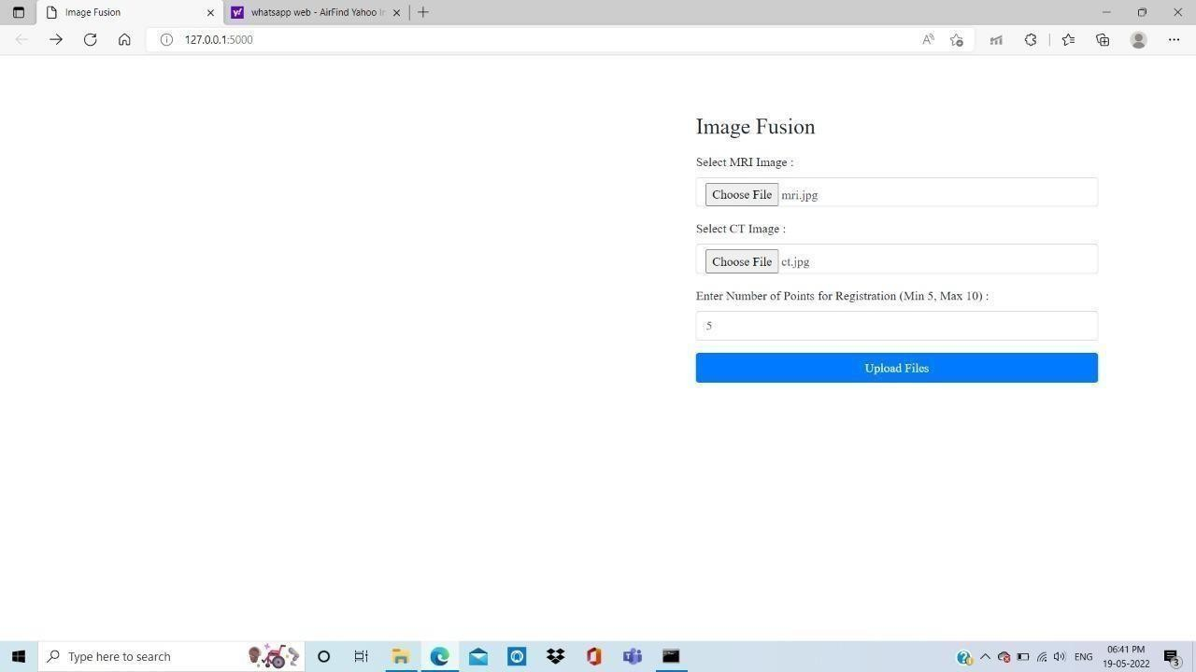

Fig A 1.1 Upload page in image fusion

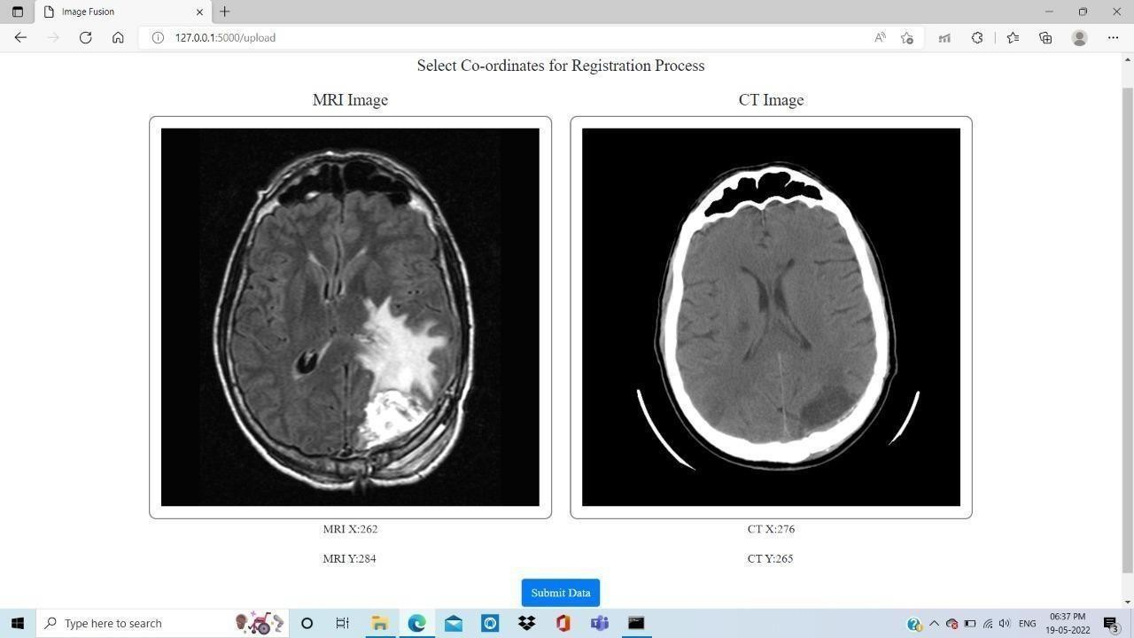

Fig A 1.2 Coordinates selection page in image fusion

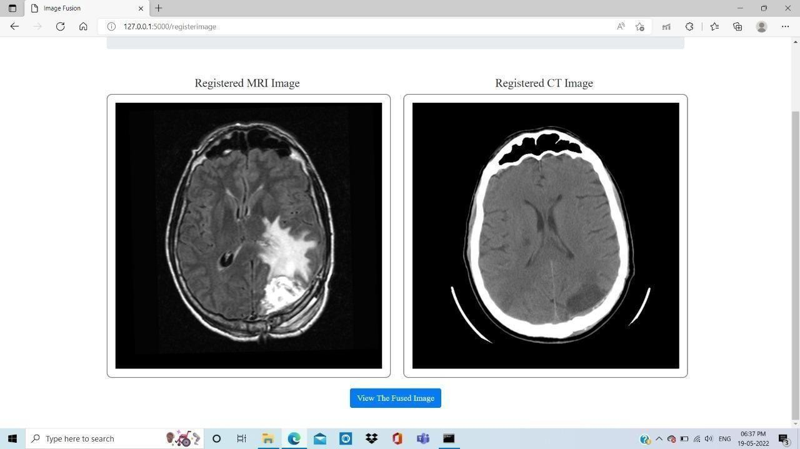

Fig A 1.3 Registered images display page in image fusion

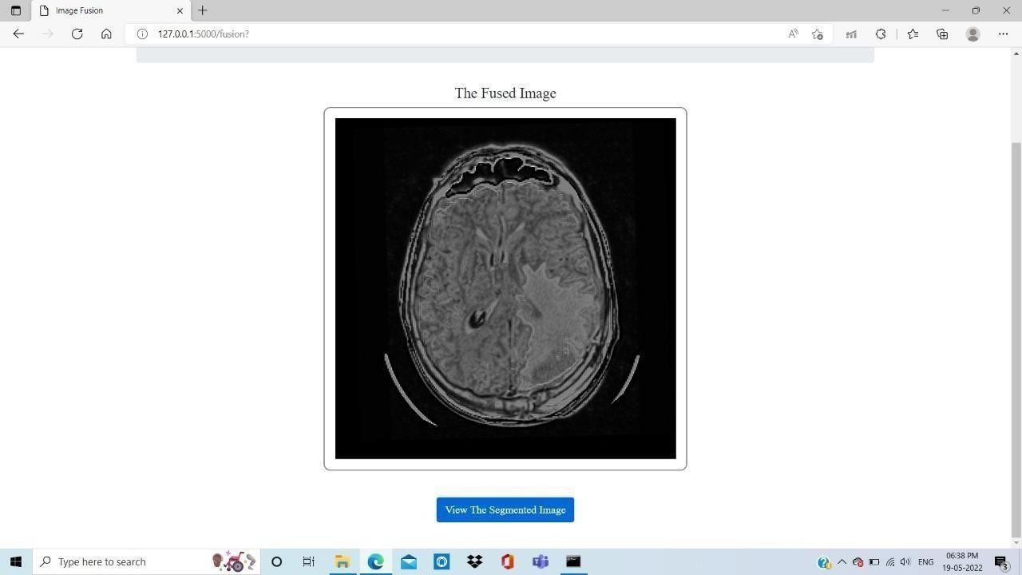

Fig A 1.4 Fused image display page in image fusion

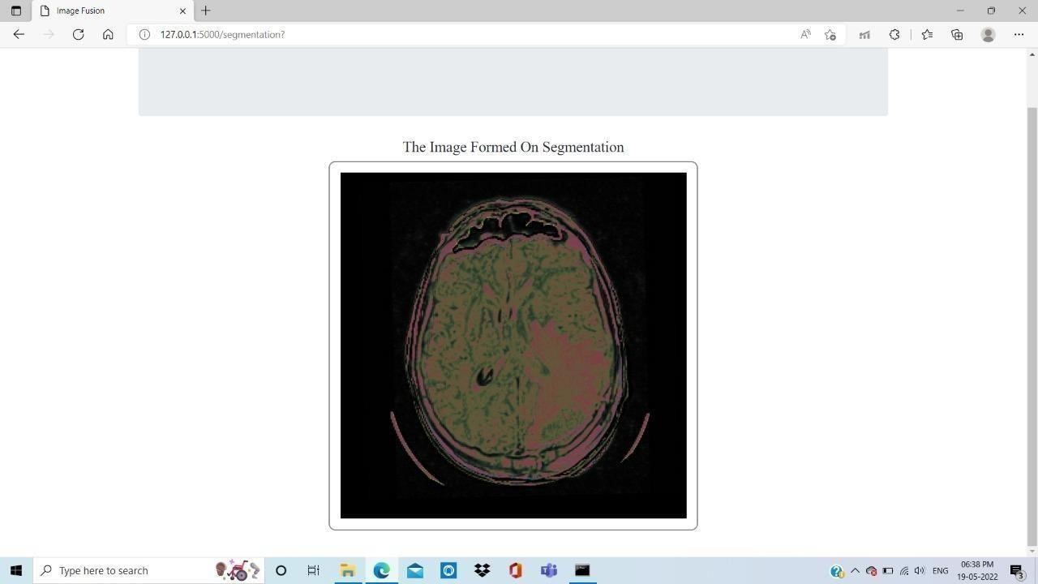

Fig A 1.5 Segmented image display page in image fusion

### REFERENCES

1. Tannaz akbarpour, Mousa shamsi, Sabalan Daneshvar, “Structural medical image fusion by means of dual tree complex wavelet”, The 22nd Iranian Conference on Electrical engineering (ICEE 2014), pp.1970- 1975, May 20-22, 2014.
2. Padmavathi K, Maya V KarKi, Mahima Bhat, “Medical Image Fusion of Different Modalities Using Dual Tree Complex Wavelet Transform With PCA”, 2016 International Conference on Circuit, Communication and Computry (I4C), October 2016.
3. Rajiv Singh, Richa Srivastava, Om Prakash and Ashish Khare, “Mixed scheme based multimodal medical image fusion using Daubechies Complex Wavelet Transform”, IEEE/OSA/IAPR International Conference on Informatics, Electronics & Vision, (ICIEV), pp. 304-309, 2012.
4. Negar Chabi, Mehran Yazdi, Mohammad Entezarmahdi, “An efficient image fusion method based on dual tree complex wavelet transform”, 8th IEEE Iranian Conference on Machine Vision and Image Processing (MVIP), pp. 403-407, 2013.
5. Ivan W. Selesnick, Richard G. Baraniuk, Nick G. Kingsbury, “The Dual-Tree Complex Wavelet Transform, A coherent framework for multiscale signal and image processing”, IEEE, signal processing Magazine, pp.123-151 Nov-2005.
6. Himanshi, Vikrant Bhaterja Abhinav Krishn, and Akanksha Sahu, “An improved Medical Image Fusion Approach Using PCA and Complex Wavelets”, IEEE International conference on Medical Imaging, m- Health and Emerging Communication systems (MedCom) , pp. 442-447, 2014.
7. Sruthy S, Dr. Latha Parameswaran , Ajeesh P Sasi, “Image Fusion Technique using DT-CWT”, IEEE, pp. 160-164, 2013.
8. Sonali Mane, S.D. Sawant, “Image Fusion of CT/MRI using DWT, PCA

Methods and Analog DSP Processor”, International Journal of Engineering

Research and Applications ISSN:2248-9622, Vol. 4, Issue 2(Version 1), pp.557- 563, February 2014.

1. Rajiv Singh, Ashish Khare, “Multimodal medical image fusion using Daubechies complex wavelet transform”, Proceedings of IEEE Conference on information and communication technologies (ICT) ,pp. 869-873, 2013.
2. P.R.Hill, D.R.Bull & C.N Canagarajah, “Image fusion using a new framework for complex wavelet transform”, IEEE, September, 2005.
3. J. Ruf, E. Lopez Hänninen, M. Böhmig, I. Koch, T. Denecke, M. Plotkin, et al. “Impact of FDG-PET/MRI Image fusion on the Detection of Pancreatic Cancer”

. *pancheratology* , vol.6, pp.512-519, 2006.

1. I. Jambor, R. Borra, J.Kemppainen, V.Lepomäki, R.Parkkola, K. Dean, et al.” Improved detection of localized prostate cancer using co-registered MRI and 11C-acetate PET/CT” , *Europian Journal of Radiology,* vol.81 , pp. 2966-2972, 2012.
2. S.Kor,U.S.Tiwary,” feature level fusion of multimodal medical images in lifting wavelet transform domain*”, Engineering in Medicine and biology Society,2004.IEEE-EMBs. 26th Annual Conference of the*, On page(s) 1479- 1482.
3. I.W.Selesnick, R.G.Baraniuk, N.C.Kingsbury. “ The dual tree complex wavelet transform “ . *Signal processing magazine*,vol.22,pp. 123-151,2005.
4. J.Magarey, N.C.Kingsbury. “ Motion estimation using a complex- valued wavelet transform”. *Signal Processing , IEEE transactions on,* vol.46,pp.1069- 1084,1998.
5. W.Wang,P.Shui, G.Song. “Multifocus image fusion in wavelet domain”. *Machine Learning and Cybernetics, 2003 International Conference on,*2003,pp.2887-2890.
6. B.Yang,S.Li. “ Pixel level image fusion with simultaneous orthogonal matching pursuit”. *Information fusion,* vol.13, pp 10-19,2012..
7. S.Li,J.T.Kwok, Y.Wang. “ Multifocus image fusion using artificial neural

networks” . Patteren recognition letters, vol.23, pp.985- 997,2002.

1. S.Daneshvar, H.Ghasemian.”MRI and PET image fusion by combining IHS and retina-inspired models”. *Information fusion*,vol.12 ,pp.114-123, 2010.
2. A.Toet, J.J.Van Ruyven, J.M,Valeton. “ Merging thermal and visual images by a contarst pyramid” . *Optical engineering* ,vol.28,pp.789- 792,1989